SOFTWARE

REQUIREMENTS SPECIFICATION

For

ONLINE QUIZZ SYSTEM

Prepared by:-

RAGUL PRASANTH.R (22EC115)

NAVANEETHAN.CK(22EC091)

PRAJITH.R(22EC105)
1. Introduction
1.1 Purpose

The main objective of this document is to illustrate the requirements of the project Online Quizz system. The document gives the detailed description of the both functional and non-functional requirements proposed by the client. The purpose of this project is to provide a online quizzes motivate you to do better every time you take a quiz. These quizzes are engaging and make students work on the question with more dedication. The more the involvement of students ,the more knowledge they gain. This project describes the hardware and software interface requirements using ER diagrams and UML diagrams.

1.2 Document Conventions
- Entire document should be justified.

- Convention for Main title

- Convention for Sub title

- Convention for body
Font face: Times New Roman

Font Size: 12

1.3 Scope of Development Project

Online Quiz system is basically updating the manual Quizzes are intended to encourage fun learning methods while also enhancing general knowledge. Students can think outside the box or from diverse perspectives by participating in quiz tournaments.it encourages constructive dialogue among participants so they can benefit from one another.

The project can be easily implemented under various situations. We can add new features as and when we require, making reusability possible as there is flexibility in all the modules.

The language used for developing the project is Java as it is quite advantageous than other languages in terms of performance, tools available, cross platform compatibility, libraries, cost (freely available), and development process.

1.4 Definitions, Acronyms and Abbreviations
JAVA -> platform independence

SQL-> Structured query Language
ER-> Entity Relationship
UML -> Unified Modeling Language
IDE-> Integrated Development Environment
SRS-> Software Requirement Specification

1.5 References

Websites
*

- Overall Descriptions
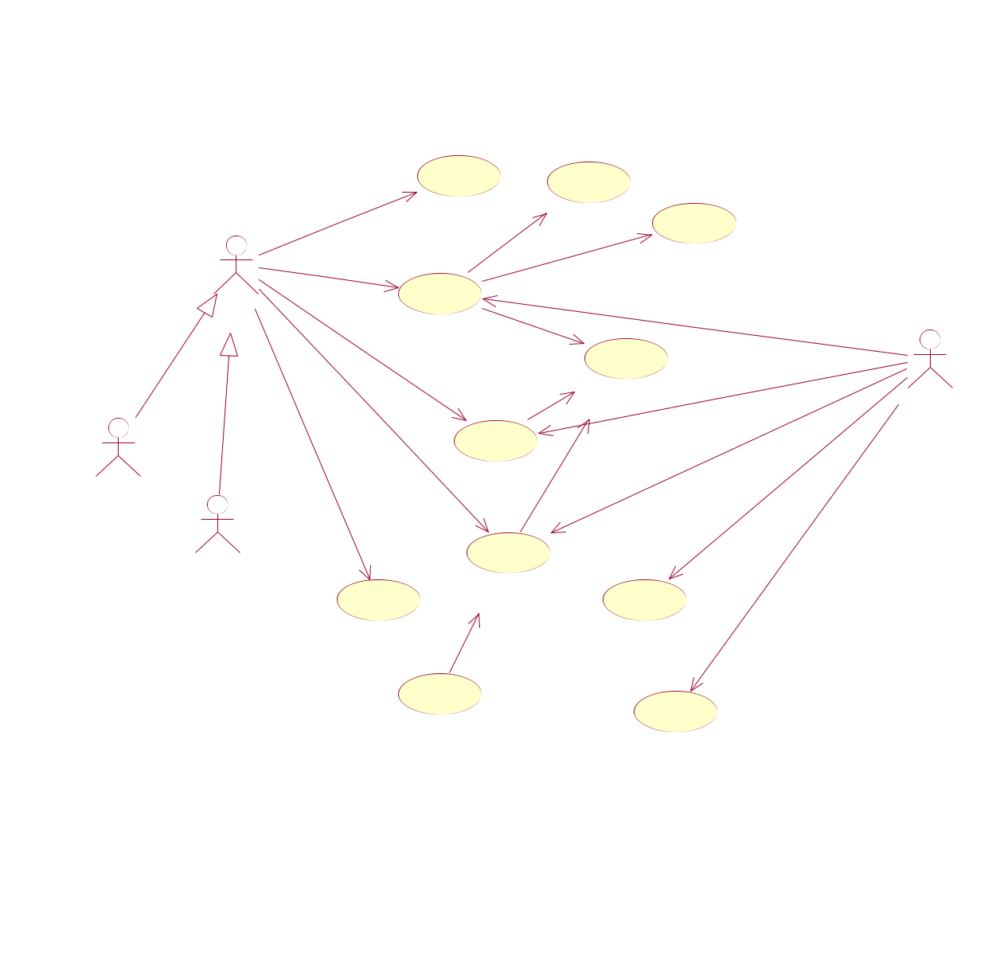
2.1 Product Perspective
Use Case Diagram of Online quiz system

 | *
 | searches
 |  | search_quizz | check_limit
1
 | ₁requests |  |  |  |  | check_availability
 | 1..* |  |  |  |  | check_availability
 | 1 | 1..*
 | 1 | 1..*
User | 1 |  |  |  |  | monitors_request
User | 1 |  |  |  |  | monitors_request
 | _{issue_quizz} <<include>> |  |  |  |  |  | 1
 | request_renew |  |  |  |  |  | 1
 |  |  |  |  |  |  | 1₁
 |  | <<include>> |  |  |  | monitors_renew | 1₁
performs |  |  |  |  | verify_member |  | 1
 |  | 0..* |  |  |  |  | ₁ Online quiz
 | give_quizz |  |  |  |  | tak e_quizz | ₁ Online quiz
 | give_quizz | 1..* |  |  |  | tak e_quizz
 |  | renew_quizz |  | <<include>>
Student |  | renew_quizz
Student |  |  | 1..* |  |  | adds_new_quizz
 |  | 0..*
 |  |  |  |  |  | perform_transaction_updation
Staff | * |  |  |  |  | *
 |  | return_quizz
 | View_logs | <<extend>> |  |  |  | add_quizz
 |  |  |  |  |  | *
 | calculate_fine
 |  |  |  |  |  | update_record

This is a broad level diagram of the project showing a basic overview. The users can be either staff or student.. This System will provide a search functionality to facilitate the search of resources. This search will be based on various categories viz. book name or the ISBN. Further the library staff personnel canadd/update the resources and the resource users from the

system.The users of the system can request issue/renew/return of books for which they would have to follow certain criteria.

2.2 Product Function
Entity Relationship Diagram of Online Quizz system

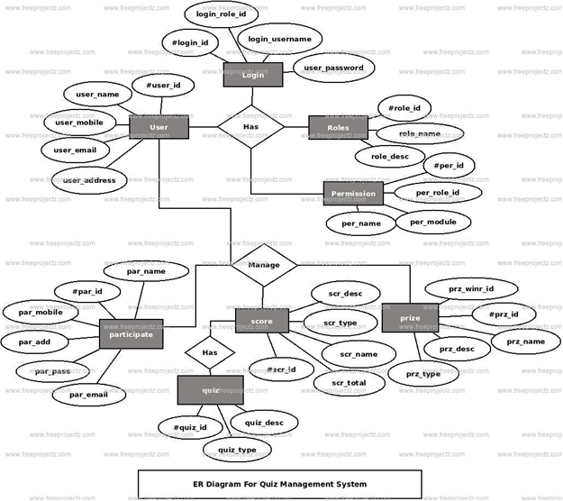

2.3 User Classes and Characteristics
2.3 User Classes and Characteristics There are various kinds of users for the product. Usually web products are visited by various users for different reasons. The users include : ¬ Chancellor who will be acting as the controller and he will have all the privileges of administrator. ¬ Students who will be using the above features by accessing the OES online. ¬ Examiner who will prepare& load database into the software.

The features that are available to the Members are:-

There are three different users who will be using this product:
¬ University chancellor who will be acting as the administrator.
¬ Students who will be accessing the OES online.
The features that are available to the Administrator are:
¬ The administrator has the full fledged rights over the OES.
¬ Can create/delete an account.
¬ Can view the accounts.
¬ Can change the password.
¬ Can hide any kind of features from the both of users.
¬ Insert/delete/edit the information of available on OES.
¬ Can access all the accounts of the faculty members/students.
The features available to the Students are:
¬ Can view The different categories of Test available in their account.
¬ Can view their marks.
¬ Can view the various reading material.
¬ Can view and modify its profile but can modify it to some limited range. The features available to the Examiner are:
¬ Can view The different categories of Test conducted by users.
¬ Can view their marks.
¬ Can view and modify Results

2.4 Operating Environment

The product will be operating in windows environment. Also it will be compatible with the IE 6.0. Most of the features will be compatible with the Mozilla Firefox & Opera 7.0 or higher version. The only requirement to use this online product would be the internet connection.

2.5 Assumptions and Dependencies
The assumptions are:-
- The coding should be error free

- The system should be user-friendly so that it is easy to use for the users

- The system should have more storage capacity and provide fast access to the database

- The system should provide search facility and support quick transactions

- The Online quizz System is running 24 hours a day

- Users may access from any computer that has Internet browsing capabilities and an
Internet connection

- Users must have their correct usernames and passwords to enter into their online accounts and do actions

The dependencies are:-
- The specific hardware and software due to which the product will be run

- On the basis of listing requirements and specification the project will be developed and run

- The end users (admin) should have proper understanding of the product

- The system should have the general report stored

- The information of all the users must be stored in a database that is accessible by the online quizz System

- Any update regarding the book from the library is to be recorded to the database and the data entered should be correct

2.6 Requirement
Software Configuration:-

This software package is developed using java as front end which is supported by sun micro system. Microsoft SQL Server as the back end to store the database. Operating System: Windows NT, windows 98, Windows XP

Language: Java Runtime Environment, Net beans 7.0.1 (front end)
Database: MS SQL Server (back end)

Hardware Configuration:-
Processor: Pentium(R)Dual-core CPU
Hard Disk: 40GB
RAM: 256 MB or more

2.7 Data Requirement

The inputs consist of the query to the database and the output consists of the solutions for the query. The output also includes the user receiving the details of their accounts. In this project the inputs will be the queries as fired by the users like create an account, selecting books and putting into account. Now the output will be visible when the user requests the server to get details of their account in the form of time, date and which books are currently in the account
Login Interface:-

In case the user is not yet registered, he can enter the details and register to create his account. Once his account is created he can ‘Login’ which asks the user to type his username and password. If the user entered either his username or password incorrectly then an error message appears.

Search:-

The member or librarian can enter the type of book he is looking for and the title he is interested in,then he can search for the required book by entering the book name.

Categories View:-

Categories view shows the categories of books available and provides ability to the librarian to add/edit or delete category from the list.

Librarian’s Control Panel:-

This control panel will allow librarian to add/remove users; add, edit, or remove a resource. And manage lending options.

4. System Features

The users of the system should be provided the surety that their account is secure. This is possible by providing:-
  - User authentication and validation of members using their unique member ID

  - Proper monitoring by the administrator which includes updating account status, showing a popup if the member attempts to issue number of books that exceed the limit provided by the library policy, assigning fine to members who skip the date of return

  - Proper accountability which includes not allowing a member to see other member’s account. Only administrator will see and manage all member accounts

- Other Non-functional Requirements
5.1 Performance Requirement

The proposed system that we are going to develop will be used as the Chief performance system within the different campuses of the university which interacts with the university staff and students. Therefore, it is expected that the database would perform functionally all the requirements that are specified by the university.
- The performance of the system should be fast and accurate

- ONLINE QUIZZ System shall handle expected and non-expected errors in ways that prevent loss in information and long downtime period. Thus it should have inbuilt error testing to identify invalid username/password

- The system should be able to handle large amount of data. Thus it should accommodate high number of books and users without any fault

5.2 Safety Requirement

The database may get crashed at any certain time due to virus or operating system failure. Therefore, it is required to take the database backup so that the database is not lost. Proper UPS/inverter facility should be there in case of power supply failure.

5.3 Security Requirement
- System will use secured database

- Normal users can just read information but they cannot edit or modify anything except their personal and some other information.

- System will have different types of users and every user has access constraints

- Proper user authentication should be provided

- No one should be able to hack users’ password

- There should be separate accounts for admin and members such that no member can access the database and only admin has the rights to update the database.

5.4 Requirement attributes

- There may be multiple admins creating the project, all of them will have the right to create changes to the system. But the members or other users cannot do changes
- The project should be open source

- The Quality of the database is maintained in such a way so that it can be very user friendly to all the users of the database

- The user be able to easily download and install the system

5.5 Business Rules

A business rule is anything that captures and implements business policies and practices. A rule can enforce business policy, make a decision, or infer new data from existing data.This includes the rules and regulations that the System users should abide by. This includes the cost of the project and the discount offers provided. The users should avoid illegal rules and protocols. Neither admin nor member should cross the rules and regulations.

5.6 User Requirement

The users of the system are members and Online quizz of the university who act as administrator to maintain the system. The members are assumed to have basic knowledge of the computers and internet browsing. The administrators of the system should have more knowledge of the internals of the system and is able to rectify the small problems that may arise due to disk crashes, power failures and other catastrophes to maintain the system. The proper user interface, user manual, online help and the guide to install and maintain the system must be sufficient to educate the users on how to use the system without any problems.

The admin provides certain facilities to the users in the form of:-
- Backup and Recovery

- Forgot Password

- Data migration i.e. whenever user registers for the first time then the data is stored in the server

- Data replication i.e. if the data is lost in one branch, it is still stored with the server

- Auto Recovery i.e. frequently auto saving the information

- Maintaining files i.e. File Organization

- The server must be maintained regularly and it has to be updated from time to time

6. Other Requirements
6.1 Data and Category Requirement

There are different categories of users namely teaching staff, Admin, students etc. Depending upon the category of user the access rights are decided.It means if the user is an administrator then he can be able to modify the data,delete, append etc. All other users except the only have the rights to retrieve the information about database.

6.2 Appendix

Member;N:Non-functionalRequirement;O:Operatingenvironment;P:
Performance,Perspective,Purpose; R: Requirement, Requirement attributes; S: Safety, Scope,
Security, System features; U: User, User class and characteristics, User requirement;

6.3 Glossary

The following are the list of conventions and acronyms used in this document and the project as well:

- Administrator: A login id representing a user with user administration privileges to the software

- User: A general login id assigned to most users

- Client: Intended users for the software
➢ SQL: Structured Query Language; used to retrieve information from a database
- SQL Server: A server used to store data in an organized format

- Layer: Represents a section of the project

- User Interface Layer: The section of the assignment referring to what the user interacts with directly

- Application Logic Layer: The section of the assignment referring to the Web Server. This is where all computations are completed
- Data Storage Layer: The section of the assignment referring to where all data is recorded

- Use Case: A broad level diagram of the project showing a basic overview

- Class diagram: It is a type of static structure diagram that describes the structure of a system by showing the system’s cases, their attributes, and the relationships between the classes
- Interface: Something used to communicate across different mediums

- Unique Key: Used to differentiate entries in a database

6.4 Class Diagram

A class is an abstract, user-defined description of a type of data. It identifies the attributes of the data and the operations that can be performed on instances (i.e. objects) of the data. A class of data has a name, a set of attributes that describes its characteristics, and a set of operations that can be performed on the objects of that class. The classes’ structure and their relationships to each other frozen in time represent the static model. In this project there are certain main classes

which are related to other classes required for their working. There are different kinds of relationships between the classes as shown in the diagram like normal association, aggregation, and generalization. The relationships are depicted using a role name and multiplicities. Here ‘online quizz’ are the most important classes which are related to other classes.
